Test Set with 27 tests.
3 unique tests but each test is repeated for 9 instances in the same test.
The reason for the duplicates is that each test instance is targeted to a specific PC.
Delete temp files (where the test runs)
Copy File to PC (where the test runs)
Reboot PC (where the test runs)
Jenkins logs show details for all 9 tests except for Pass/Fail status. The test status only shows for instance [9]. See screenshot. Attached full log file too this word document.
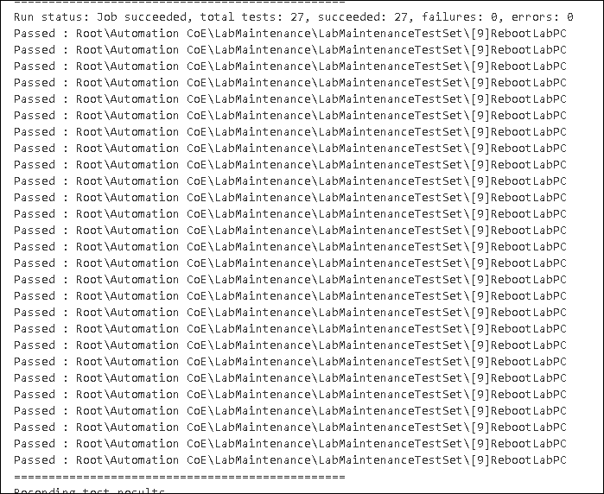

Test Set with 213 different Test Cases.
Jenkins console output (log) shows the same test case for 213 times instead of all the other tests in the Test Set.
Test is about to run is listed in the log only once. Note that it is listed in the log file 213 times.
Please see screenshot.
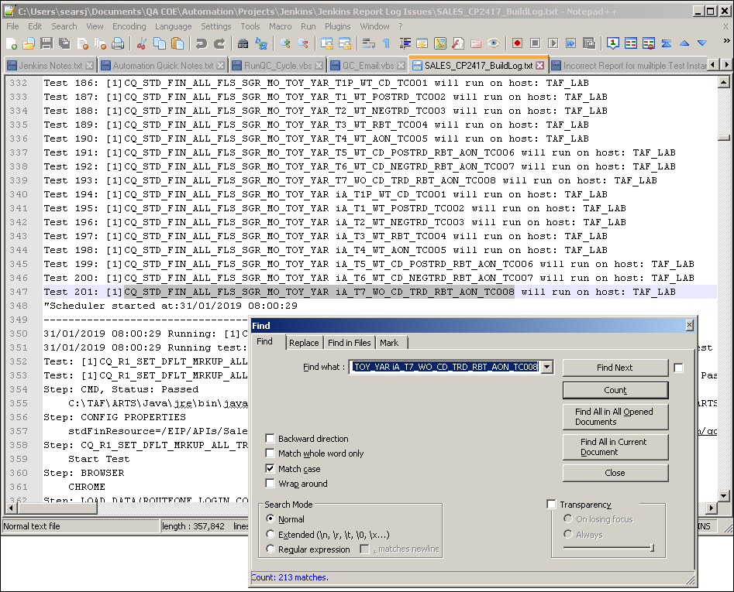

In the report that shows execution status, this test appears 200 times for the same instance instead of showing the other tests that have passed.
CQ_STD_FIN_ALL_FLS_SGR_MO_TOY_YAR iA_T7_WO_CD_TRD_RBT_AON_TC008
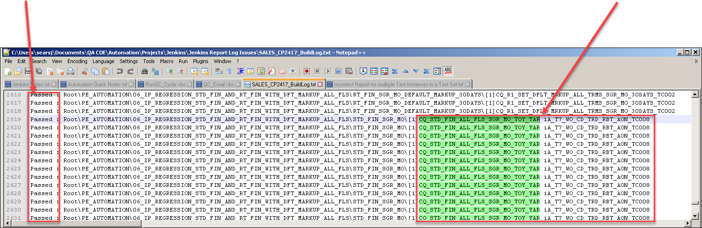

There appears to be a bug with iteration of the tests in the Test Set.

